16 Creating Enemies

The main subject for this tutorial is to create a few enemies for our hero to fight, But first I think I might want to spruce up the dungeon floor just a bit. I tried adding brick or stone floors, but the elements did not show up very well, so I decided I need a darker floor. Yes, black marble isn’t exactly what is on most dungeon floors, but it just looked so cool, I decided to keep it.

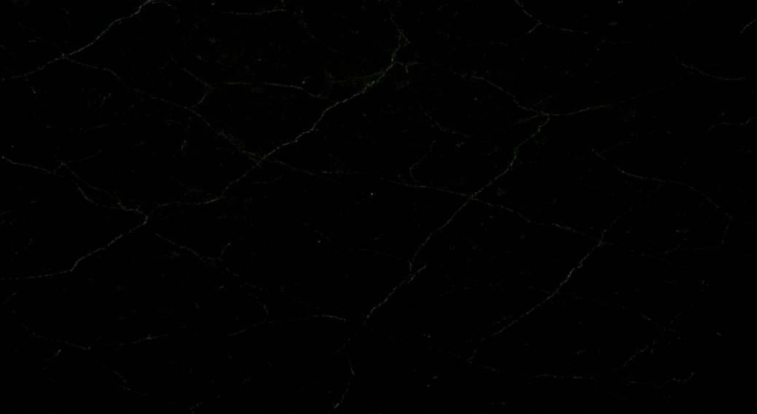

We need our floor to come in at a size of 1280 x 704. Create a sprite for it through the sprite panel and then just assign the sprite to the room’s background layer.

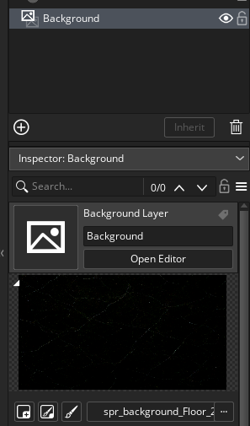

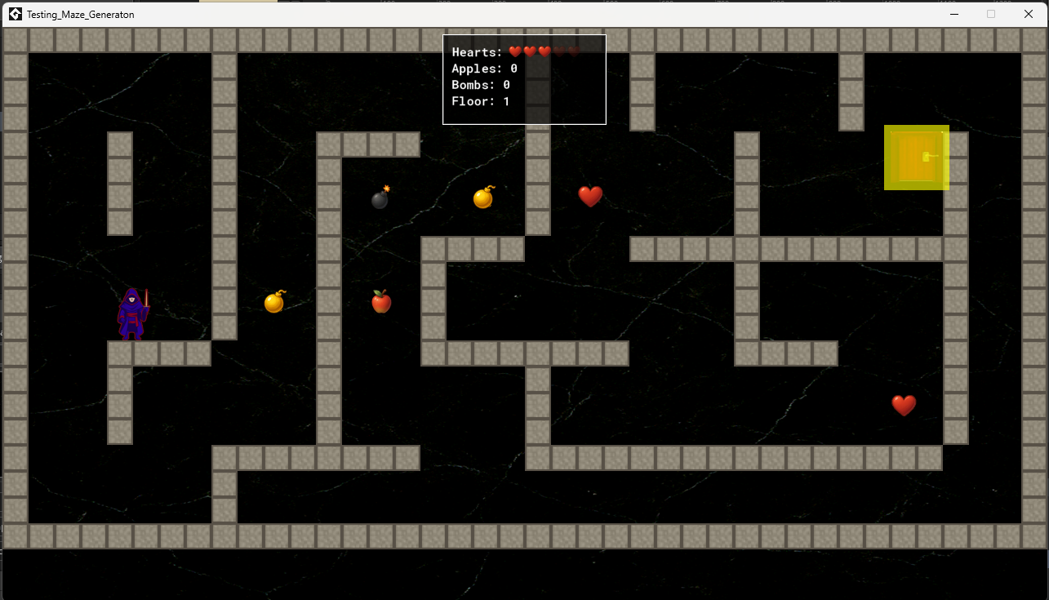

# Creating the Enemies

Folder Structure for the Sprites will be first. We have one main folder called Enemies, inside that folder, we have a folder for each type of enemy, then inside of each enemy folder, you need 4 folders each for each film strip.

We need a different film strip for each phase of monster behavior.

Idle

Attack

Hit

Death

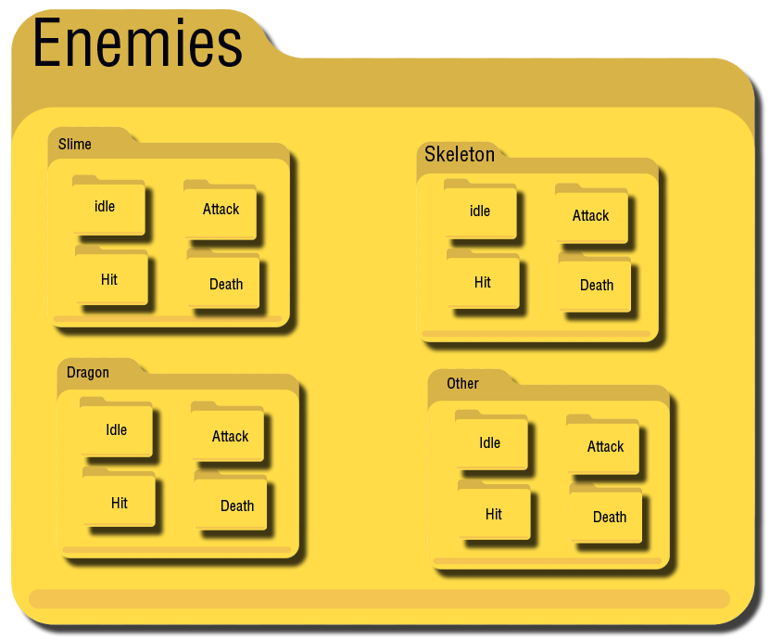

# Blue Furry Slime

This can get intense, so let us start with just a slime to begin. The images for the fight scene are **128px x 128px**.

## Idle

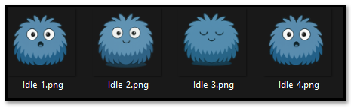

## Attack

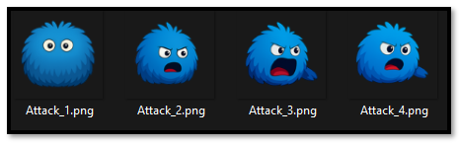

## Hit

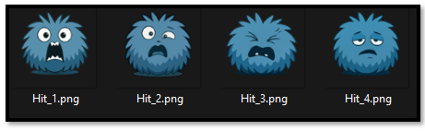

## Death

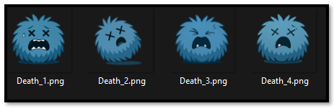

# The Hero

Ok, since our hero is only running through the maze at a size of 64px, we will need to do this images at 128, in order to meet the same size as the enemy will be during the fight. So, create a new folder in the sprite folder for our hero.

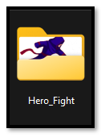

## Idle

## 

## Attack

## 

## Hit

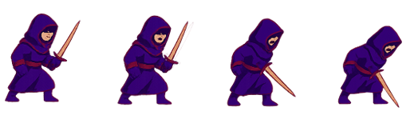

## Death



# Creating a Special Fighting Room

We need to start with a special fighting room that the characters in the fight can dual inside of. It will be a separate room from the room that holds the dungon itself. Every time the hero encounters an enemy, both of them will be sent into this room to do their fighting. So, first create the image. We will create the fighting room at the same dimensions as the dungeon room size. This is 1280px x 704px.

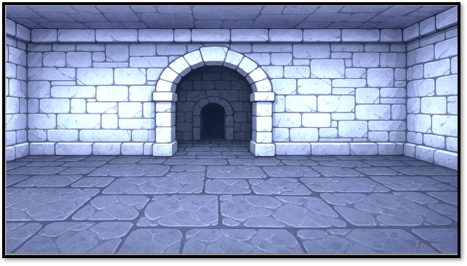

This is the way the fight room will look when we get done

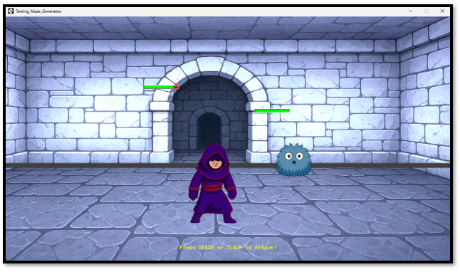

But to start, first we will need to bring our background in. Now remember for a background to work, all we need to do is to create a sprite, we do not need to create an obj for it.

spr_fight

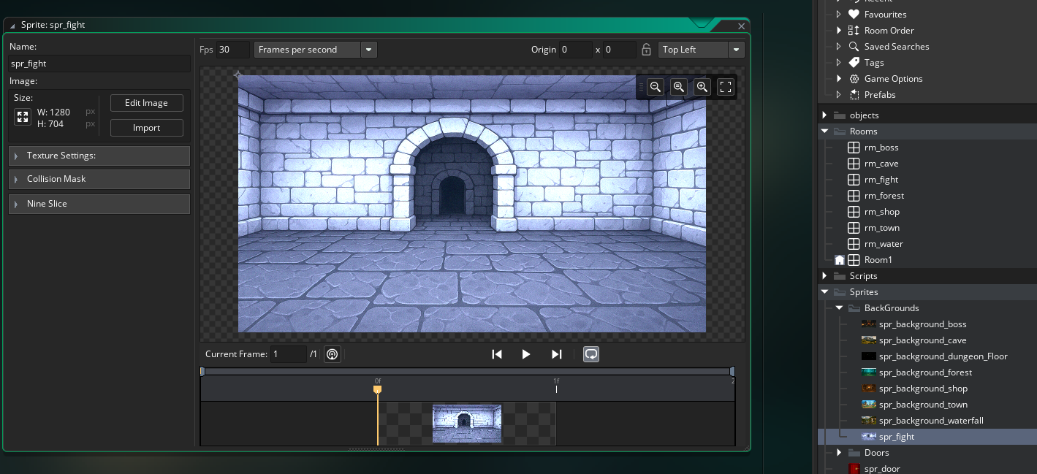

Then we need to create the room itself. Go to the Rooms folder where we have all of our rooms. Name this room:

**rm_fight**

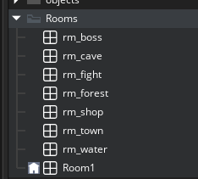

You must be in the tab for the rm_fight, to see the properties for it.

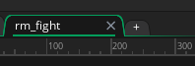

Go to the Left Pane,l and click on layers if it is not open. There you will see the background Layer. If you do not see the Background layer, just like this, make sure you have actually clicked on the rm_fight tab to display the room in the middle section of the workspace.

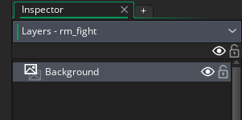

Scroll down to set the background for the room.

Check your dimensions for the room, it needs to be set to 1280px x 704px. You will need to click back on the rm_fight tab at the top of the middle section to see the section to set the dimensions.



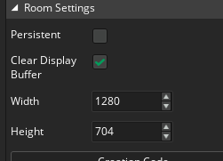

Your room background should now look like this.

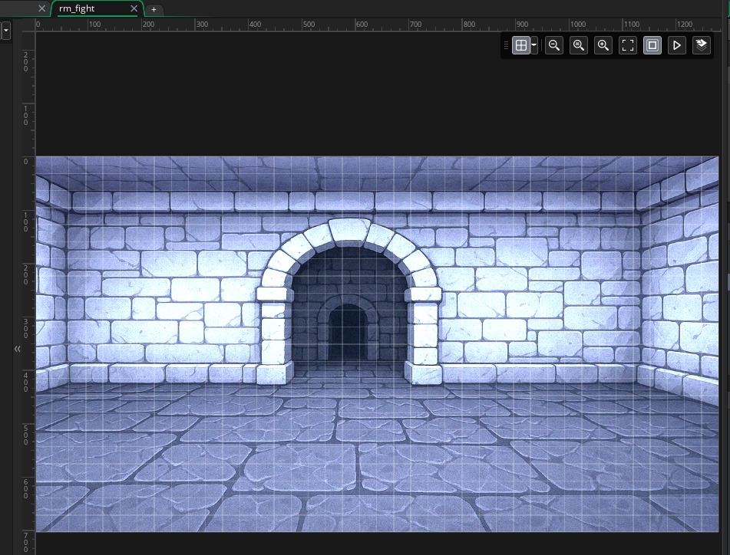

# Creating Your Sprites to Work as a short movie

Since, we do not actually just want a static image during the fight scene, and we want the fighters to actually look like they are doing some sort of magic foot work, we will need to create our sprites just a bit differently. We need to create a sprite with multiple frames.

1. **Create a Sprite with Multiple Frames**

* Go to **Sprites** → **Create Sprite**.
* Click **Import** and select all your PNGs (Idle_1.png, Idle_2.png, etc.).
* GameMaker will automatically add each image as a separate frame in the sprite.

Create the Enemy Sprites

spr_enemy_idle_128

spr_enemy_attack_128

spr_enemy_hit_128

spr_enemy_death_128

spr_hero_idle_128

spr_hero_attack_128

spr_hero_hit_128

spr_hero_death_128 (optional)

Remember to add the correct sprite multi-image sequence for each sprite. It is easy, just grab all the images when browsing for it and Game Maker will put them into a strip, instead of a single image.

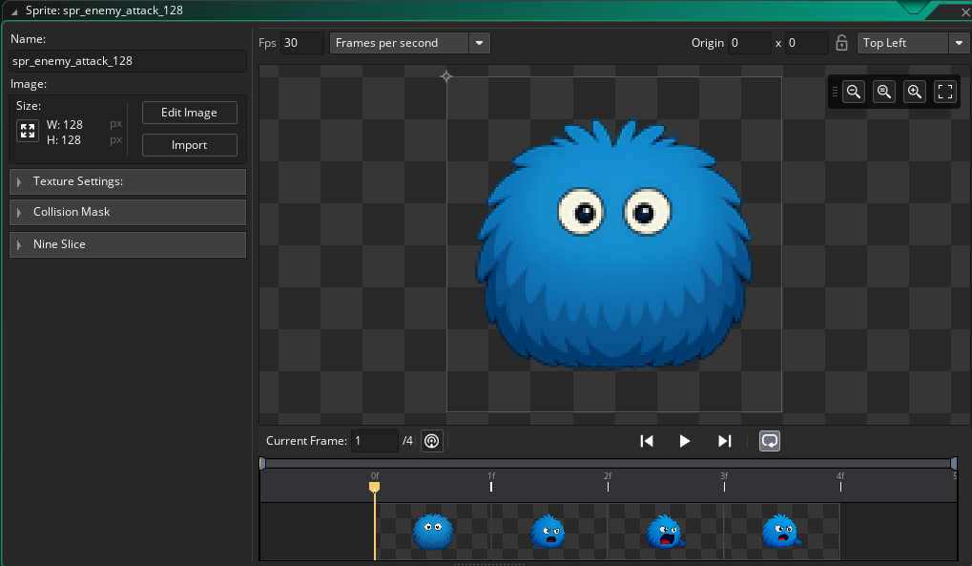

Do this for all of the different states for the enemy fight scene.

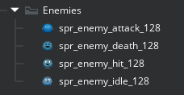

# Create the Hero Sprites

Keep the 128, at the end of the name, even though the hero is larger than 128, he will be using this exact name in the code, so just keep it like this.

spr_hero_idle_128

spr_hero_attack_128

spr_hero_hit_128

spr_hero_death_128

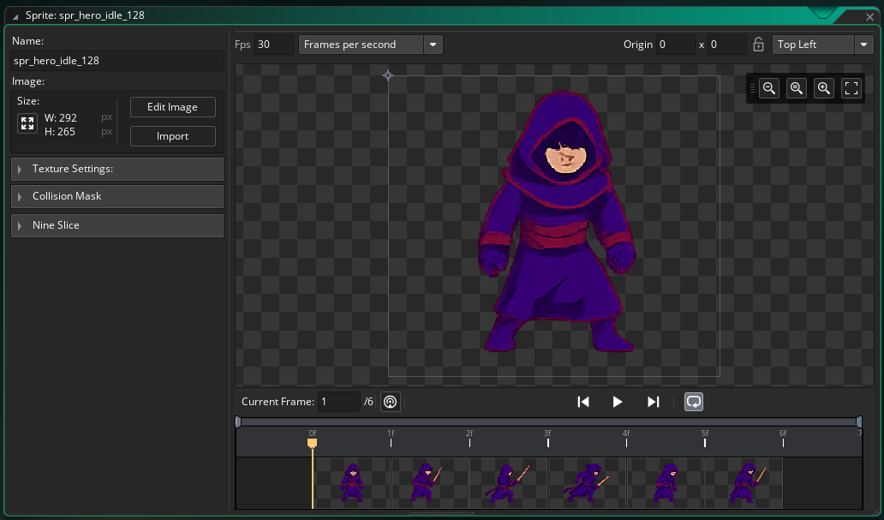

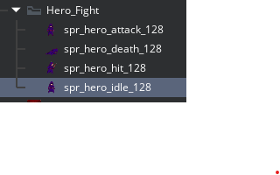

2. **Set the Animation Speed**

* In the Sprite editor, adjust the **FPS (frames per second)** to control how fast the animation plays.
* Try 8–12 FPS for idle animations — tweak until it feels right.

3. **Assign the Sprite to an Object**

* Create an **Object** and assign your multi-frame sprite to it.
* GameMaker will loop the animation automatically if the object is visible and active.

# Fixing our Hero Step Event

But before we can begin writing code for the each object in our fight scene, we need to do a bit of back tracking and make some coding changes to our Hero object.

Open the **object_hero**

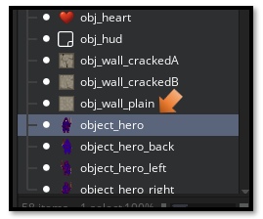

Double click on it to open up the Object code. Go into the step event. Right before the exit code,

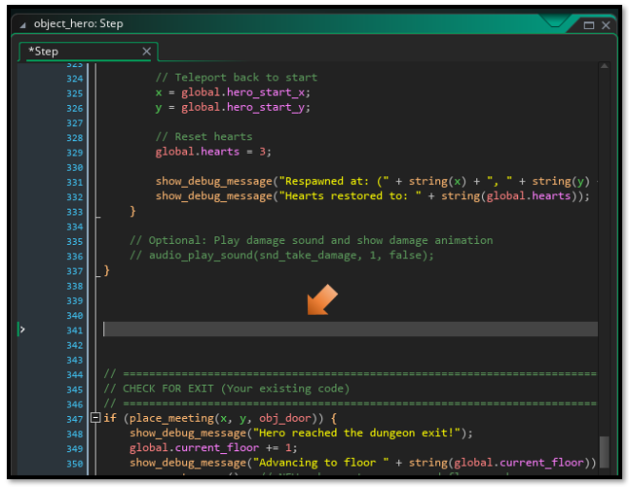

Code for the Hero Step object. Go [here](Organized%20Script%20Files%20for%20Article/1%20Hero%20Object%20Step%20Event.docx) for the code to write inside of the Hero Step Event.

# 2 Scripts

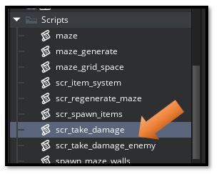

Name these two Scripts just like this:

scr_take_damage_enemy

scr_take_damage

Go [Here](Organized%20Script%20Files%20for%20Article/2%20Scripts%20for%20Taking%20Damage.docx) to find the code for these two TAKING DAMAGE Scripts

# Fixing the HUD Code

Open your obj_hud, in order to get the score board in the fight room from showing up inside of the dungeon, which makes no sense, because you are not fighting any monsters, and is just cluttering the room, you will need to make some changes to the obj_hud object. So, double click on it, to open it up and make changes to its code.

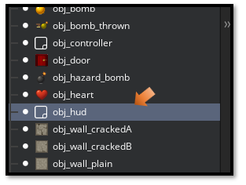

You should already have the DRAW GUI EVENT there, we will just make changes to it.

You are basically adding this top code to it.

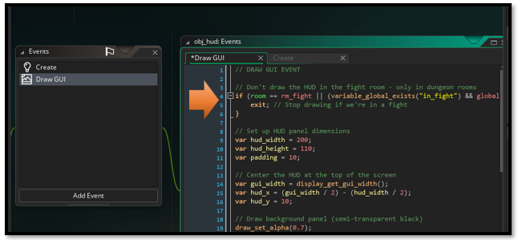

Go [Here](Organized%20Script%20Files%20for%20Article/3%20The%20HUD%20DRAW%20GUI%20EVENT.docx) for the Full code for the Draw GUI

# The Code for each of the 3 Fight Objects

The next part we will be dealing with writing the actual code for each of the fight objects

# Creating the Objects

Ok, we have all of these sprites, but when we go about creating the objects, we will only need 3 objects.

1. [obj_enemy_fight](Organized%20Script%20Files%20for%20Article/Enemy%20Fight/4%20Code%20for%20the%20Enemy%20Fight%20Object.docx)
2. [obj_hero_fight](Organized%20Script%20Files%20for%20Article/Enemy%20Fight/5%20Code%20for%20the%20Hero%20Fight%20Object.docx)
3. [obj_fight_controller](Organized%20Script%20Files%20for%20Article/Enemy%20Fight/6%20Code%20for%20the%20Controller%20Fight%20Object.docx)

Each of these objects will have 3 events.

1. Create
2. Step
3. Draw